

**BAHIRDAR UNIVERSITY**

**BAHIR DAR UNIVERSITY OF TECHNOLOGY FACULITY OF COMPUTING**

**OSSP Project**

**OSSP_individual_Yodit-Bekele-Assegid_bdu1602809_B**

**Submitted to: Wendimu Baye**

# Acknowledgment

I would like to extend my deepest gratitude to Wendimu Baye, Whose insightful guidance and unwavering support greatly contributed to the successful completion of this assignment. I am also profoundly grateful to Bahir Dar University for fostering an academic environment that encourages research and intellectual growth.

Table of Contents

Acknowledgment 1

Title: Expert Report on Open Indiana OS 3

1.Introduction (Background & Motivation) 3

1.1 Objectives 3

1.2 Historical development 4

1.3 Requirements 7

i. Hardware 7

ii. Software 7

1.4 Installation Steps 8

i.Snipped Images 8

1.5 Issues (Problem Faced) 13

1.6 File system Support 15

1.7 Advantages and Disadvantages 15

2.virtualization in modern operating systems 18

2.1 Definition:(what?) 18

2.2 Why? 19

2.3 How Virtualization Works: 20

3.System call:mount() 21

4.Conclusion 23

5. Future Outlook / Recommendations 24

# Title: Expert Report on Open Indiana OS

# 1.Introduction (Background & Motivation)

Open Indiana is a continuation of the Open Solaris project initiated by Sun Microsystems and later abandoned by Oracle. It belongs to the Illumos project, an open-source fork of the last publicly available Solaris source code. The motivation behind exploring Open Indiana is to gain deep knowledge in Unix-based systems that are built for robustness, security, and advanced file systems like ZFS. This experience is particularly valuable for understanding system-level operations, enterprise environments, and OS development. Honestly speaking I did not have a background about this operating system but now I found it nice and appropriate to do jobs specially the development and testing .(i.e. it offers tools for c, c++,python, java etc. so throughout this document we will see in detail about it.

## Objectives

* Understand the installation and configuration process of Open Indiana OS.
* Explore Open Indiana’s file system, virtualization, and desktop features.
* Identify and address common installation and usage issues.
* Evaluate its advantages, disadvantages, and usability in academic and enterprise settings.
* Preservation of Open Solaris Legacy
* Continuation of Advanced Features
* Open-Source, Community-Driven Development
* Enterprise-Grade Stability and Reliability
* Support for Virtualization and Cloud Environments
* User-Friendly Interface and Tools
* Continuous Improvement and Innovation

## 1.2 Historical development

Open Indiana is an open-source operating system derived from the now-discontinued Open Solaris, which was originally developed by Sun Microsystems. Here's a detailed overview of its historical development:

1. Sun Microsystems and the Birth of Solaris

- Early Development (1980s - 1990s): Sun Microsystems created the Solaris operating system in the 1980s, based on the UNIX System V, with additions from BSD (Berkeley Software Distribution). Solaris became a popular platform for enterprise servers, offering advanced features like ZFS (Zettabyte File System) and DTrace (dynamic tracing).

- Solaris gained attention due to its stability, scalability, and performance, especially for high-performance computing tasks and enterprise environments.

2. Acquisition by Oracle (2009)

- Oracle's Acquisition of Sun Microsystems (2009): In 2009, Oracle Corporation acquired Sun Microsystems, including Solaris. After the acquisition, Oracle made the decision to shift Solaris to a more closed-source model and eventually stopped developing it as an open-source project.

- Discontinuation of Open Solaris (2010):Oracle discontinued the Open Solaris project in 2010, which had been the open-source version of Solaris. This move frustrated the open-source community, as many had contributed to the project.

3. The Forking of Open Solaris: The Birth of Open Indiana (2010)

- Open Indiana (2010): In response to Oracle’s decision to abandon Open Solaris, the open-source community initiated a project to continue Solaris under the Open Indiana name. This was part of the Illumos project, which is a fork of the Open Solaris codebase.

- The Illumos Foundation was formed to maintain and develop this fork, with the primary aim of keeping the spirit of Open Solaris alive. Open Indiana became the distribution that used the Illumos kernel and libraries.

4. Key Features and Development

- ZFS File System: One of the key innovations brought forward from Solaris is ZFS, a high-performance file system known for its reliability, scalability, and data integrity features. ZFS quickly became one of Open Indiana’s flagship features.

- DTrace: Another notable feature carried over from Open Solaris is DTrace, a powerful dynamic tracing framework used for diagnosing performance problems and monitoring system behavior.

- Networking and Virtualization: open Indiana continued the legacy of high-performance networking and virtualization technologies introduced by Solaris. These include support for virtual machines, containers, and the SMF (Service Management Facility) for managing system services.

- User Interface: open Indiana initially focused on the command-line interface but also offered a lightweight desktop environment (Open Indiana’s default is MATE, a fork of GNOME 2).

5. Challenges and Community Involvement

- Struggles with Adoption: Although open Indiana carried forward the power of Open Solaris, it faced challenges related to limited adoption compared to more mainstream Linux distributions. Being relatively niche, it attracted mostly enthusiasts, developers, and specific enterprise users.

- Community and Development: The development of open Indiana is heavily community-driven. As an open-source project, anyone can contribute, and the Illumos and open Indiana communities worked to improve the system over the years.

- Support for Modern Hardware and Software: open Indiana worked hard to maintain compatibility with modern hardware and software environments, though it remained mostly focused on the needs of enterprises running on SPARC or x86 hardware.

6. Current Status

- open Indiana continues to evolve under the Illumos project, receiving updates and maintaining the stability and features that made Solaris famous. It has found a niche in use cases requiring strong file system and data integrity solutions.

- It remains a choice for developers who need a UNIX-based system with certain features (like ZFS and DTrace) but doesn't have as widespread a user base as Linux.

open Indiana serves as the continuation of Solaris's open-source legacy. While it hasn't become mainstream like Linux, it holds a niche position, particularly among users who need the power of the ZFS file system and other Solaris-derived features. Its development, though relatively slow in comparison to Linux, represents a dedicated effort to maintain a system rooted in the principles of scalability, reliability, and performance.

## 1.3 Requirements

### i. Hardware

- CPU: x86_64 architecture

- RAM: Minimum 2GB, 4GB recommended

- Disk: Minimum 10GB of free storage

- USB/DVD drive for boot media

### ii. Software

- Open Indiana ISO image

- Rufus (bootable media tool)

- Virtual Box (for virtualization)

- Text editor and shell terminal

## 1.4 Installation Steps

i. Step-by-Step Process

1. Download ISO from [https://www.openindiana.org](https://www.openindiana.org)

2. Use Rufus to create a bootable USB

3. Boot system from USB

4. Launch the Live Installer

5. Set hostname, time zone, and disk configuration

6. Create a user named **Yodit Bekele Assegid**

7. Reboot and login

### i.Snipped Images

1.first we create virtualbox like this

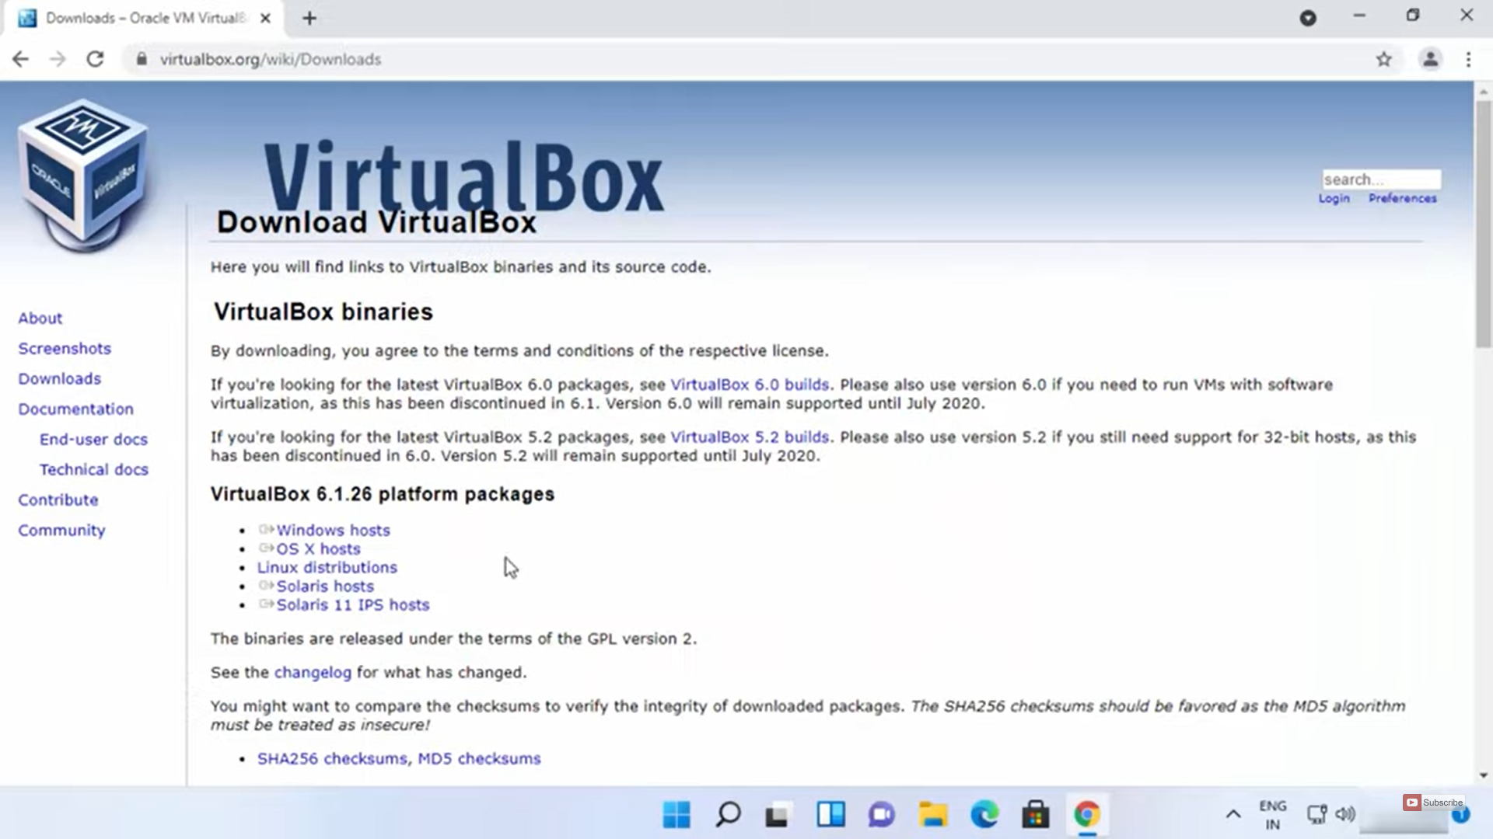

2.then we click next to continiue the process

3.wait until it installs

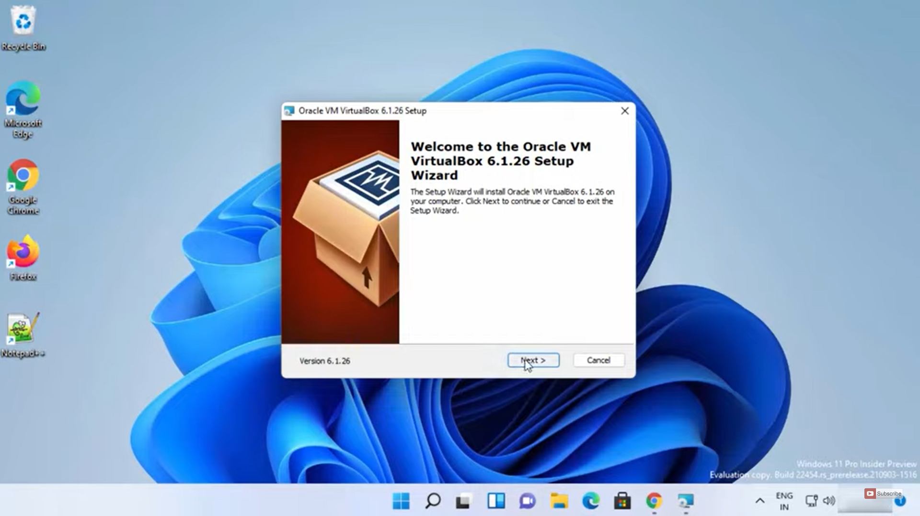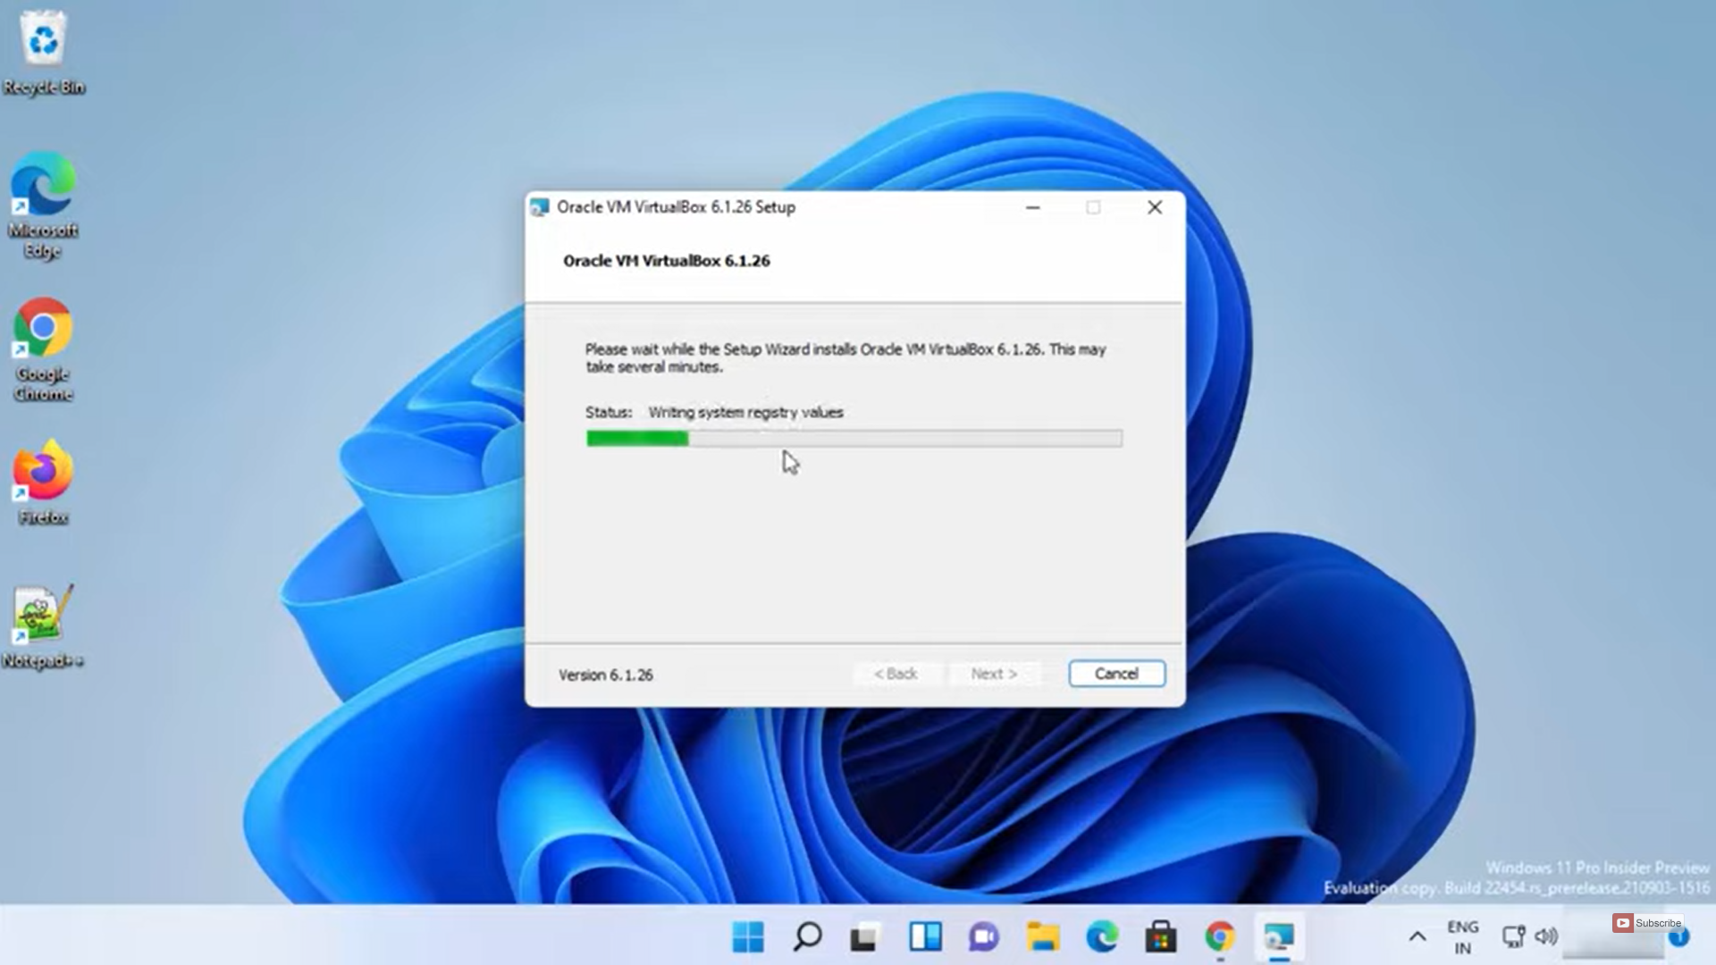

4.now we got our virtualbox ,so now we start bringing the operating system we downloaded before which is openindiana OS iso file

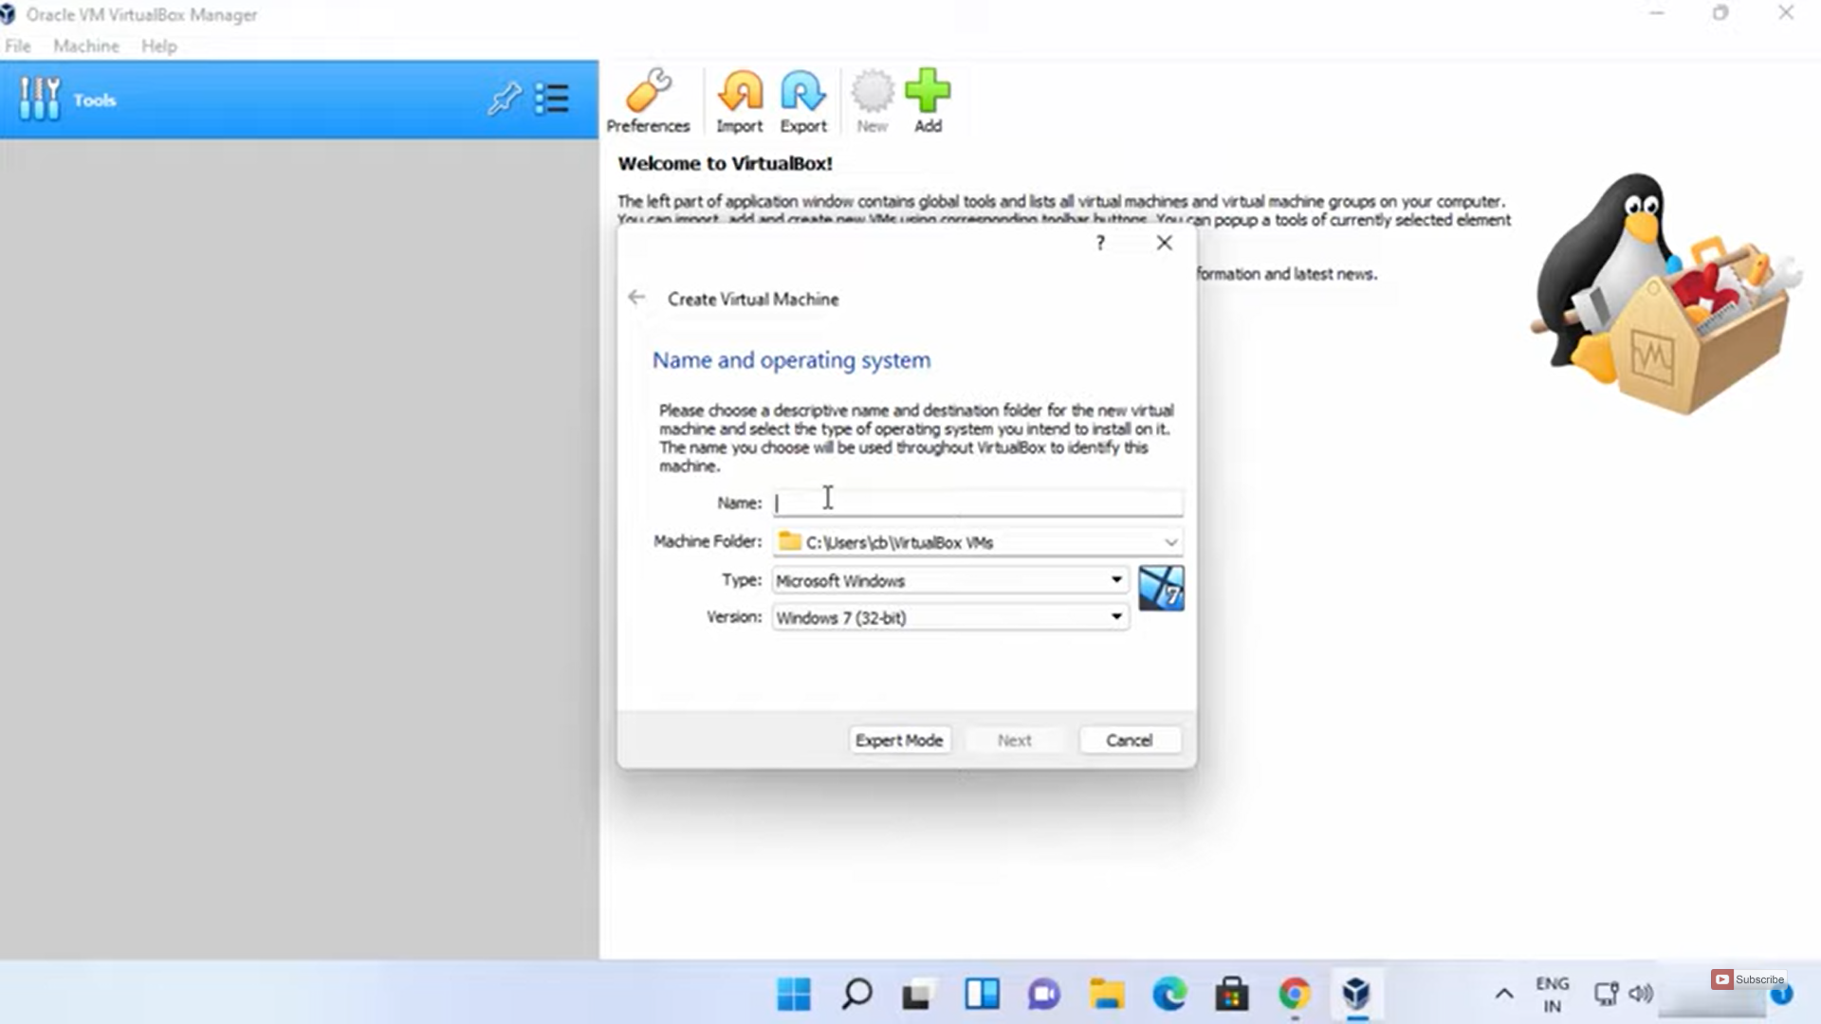

## 

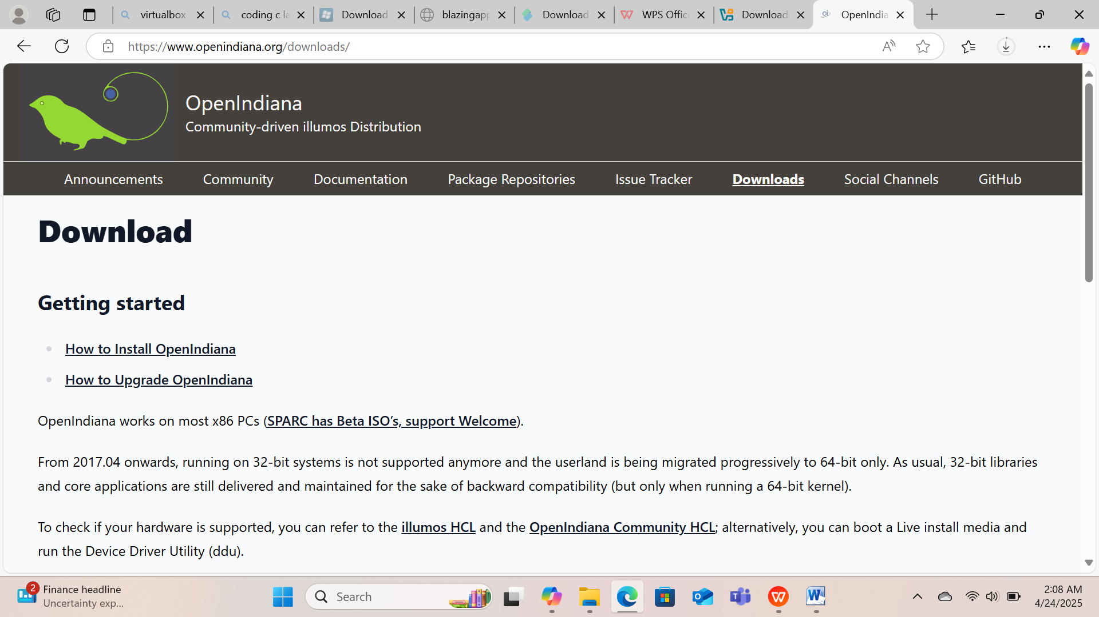

**5.After opnening lindiana we have the following structure**

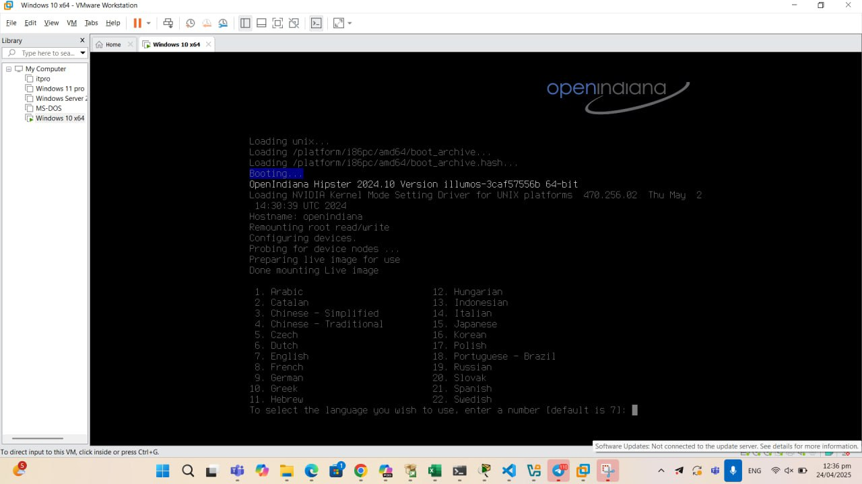

## 6. And then proceed to the next step

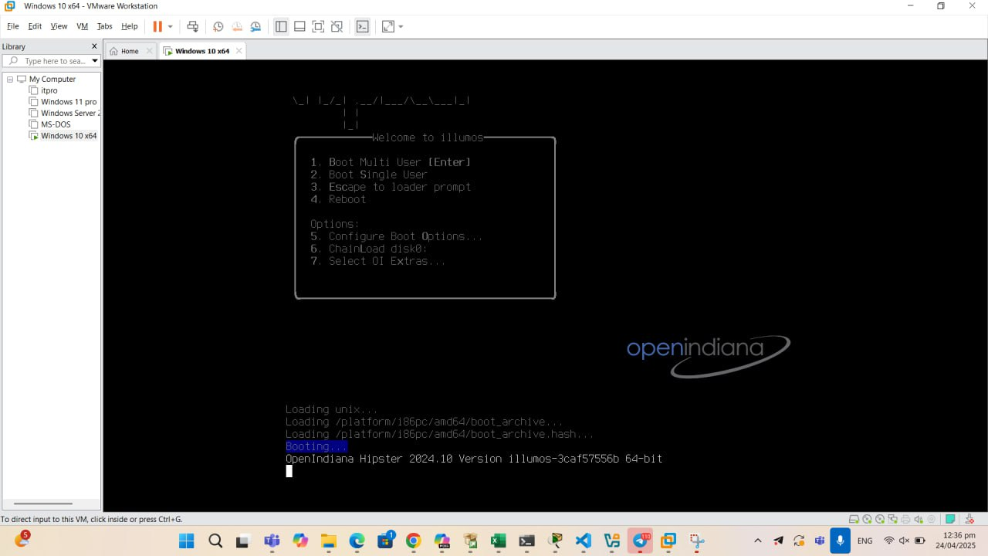

## Then,

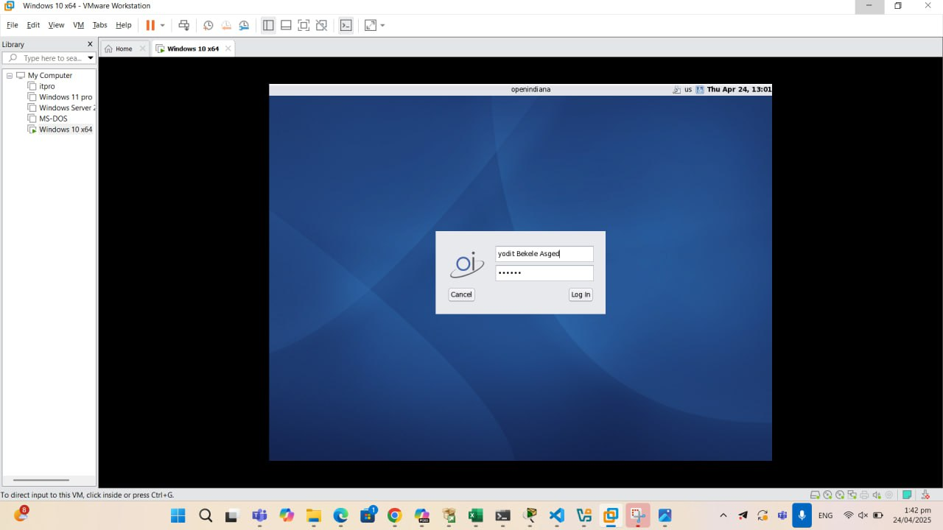

## 1.5 Issues (Problem Faced)

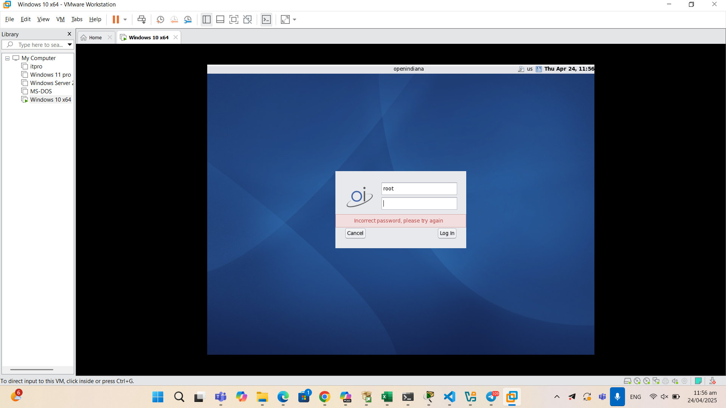

=This the above problem happened because of I incorrectly entered the password.

Solution: entering the correct password properly .

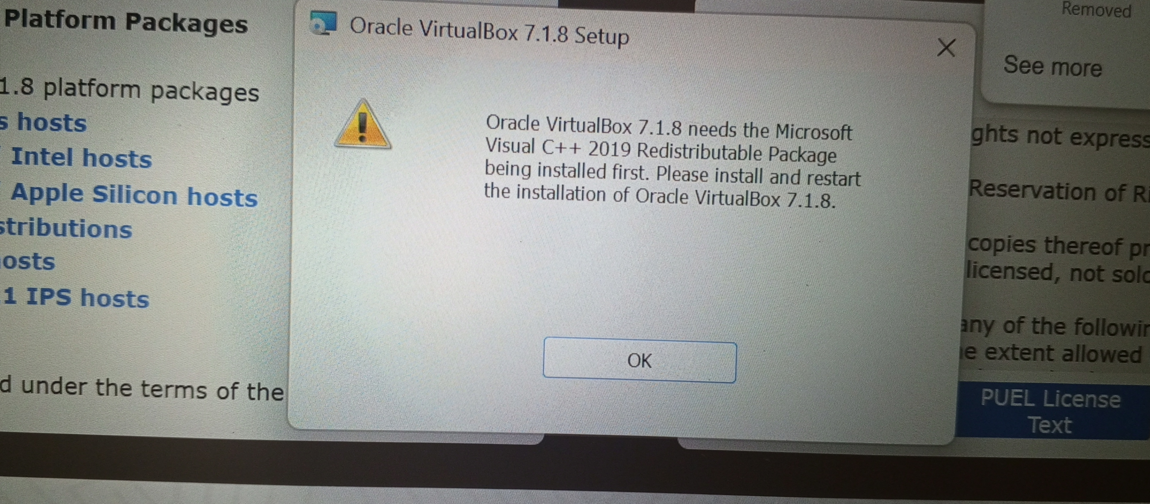

=this problem that I faced is when opening virtual box, the reason is that I did not download Microsoft visual c++ 2019 redistributable driver.

Solution: I tried it by downloading the driver and it worked out well.

But, I am not saying there are only the listed above ,here are some problems that one may face and also the solutions.

i. (To be updated after practical installation)

- Boot freeze

- Driver compatibility (Wi-Fi, display)

- Partitioning errors

**Solutions**

i. (To be updated with real-time feedback)

- Use compatibility mode

- Refer to Open Indiana community forums

- Manual configuration using terminal tools

## 1.6 File system Support

Supported: ZFS, FAT32, exFAT, NTFS (read-only), ext2/3 (via FUSE)

Why ZFS?

- Integrity checking

- Snapshots and cloning

- Data compression

- End-to-end check summing

## 1.7 Advantages and Disadvantages

Advantages of Open Indiana OS:

1. ZFS File System: Open Indiana uses the ZFS file system, which is highly regarded for its advanced features like data integrity, snapshots, compression, deduplication, and support for large-scale storage. ZFS is one of the most robust file systems available.

2. Stability and Reliability: Open Indiana, being derived from the Illumos project (which itself is a continuation of Open Solaris), is designed for high stability and reliability. It's often used in enterprise and server environments where uptime and data integrity are critical.

3. Open-Source and Free: Open Indiana is open-source, meaning users can modify the OS according to their needs without any licensing costs. It's fully free to use and distribute.

4. Security: Open Indiana comes with many built-in security features, including the Trusted Extensions (for multi-level security) and the use of zones (virtualization), which provide process isolation. It also supports features like role-based access control (RBAC) and auditing.

5. Advanced Networking Features: Open Indiana supports advanced networking tools and technologies, including IPv6, network virtualization, and robust firewall configurations. It’s ideal for users who need advanced network management.

6. Compatibility with Solaris-based Tools: Open Indiana is compatible with many tools and software packages designed for Solaris-based systems, making it an excellent choice for users who need Solaris-like functionality but with a modern, open-source foundation.

7. Enterprise-Grade Features: The system supports advanced features like high availability, fault tolerance, and data replication, making it a good choice for enterprise environments and server setups.

**Disadvantages**

1. Limited Software Ecosystem: Open Indiana’s software ecosystem is not as broad as Linux-based systems. Many popular applications and tools are not natively supported, and users may need to rely on workarounds or third-party packages, which can sometimes be outdated or incompatible.

2. Limited Hardware Support: While Open Indiana supports a wide range of hardware, it may not have the same level of compatibility with newer hardware as Linux-based systems or Windows. Drivers for certain devices (like some printers or Wi-Fi cards) may be missing or limited.

3. Less Community Support: Open Indiana has a smaller community compared to Linux distributions, meaning it can be harder to find solutions to problems or active forums where users can exchange ideas. The user base is not as large, so troubleshooting might be more difficult.

4. Learning Curve: For those coming from Linux or Windows, there is a learning curve associated with Open Indiana, especially when dealing with system administration, ZFS, and its unique command-line tools. It’s generally more suited for experienced users or those with Unix-based knowledge.

5. Not Ideal for Desktop Use: While it’s possible to use Open Indiana as a desktop OS, it’s generally more suited for server or enterprise environments. It lacks some of the desktop features and user-friendly polish found in other operating systems like Ubuntu, Fedora, or mac OS.

6. Limited Support for Popular Consumer Software: Open Indiana does not have native support for many consumer applications like Adobe software, Microsoft Office, or even major web browsers like Chrome or Firefox, in the same way that Linux or Windows do. While alternatives exist, they may not be as feature-rich or widely used.

7. Slow Development: While Open Indiana is stable, its development process can be slow at times, and it doesn’t receive as frequent updates or new features as some of the more rapidly evolving operating systems like Linux.

# 2. virtualization in modern operating systems

## 2.1 Definition :( what?)

Virtualization is the technology that allows a single physical machine to run multiple isolated environments called Virtual Machines (VMs). Each VM acts like a real computer with its own operating system and applications.

Key Components:

1. Physical Hardware– The actual machine (CPU, RAM, Disk).

2. Hypervisor – Software that manages virtual machines. It separates the hardware from the VMs.

- Type 1: Runs directly on hardware (e.g., VMware ESXi).

- Type 2: Runs on an existing OS (e.g., Virtual Box).

3. Virtual Machines (VMs) – Simulated computers running inside the host system.

4. Guest Operating System – OS installed on a VM.

5. Applications– Programs running inside each VM.

Advantages:

- Efficient resource use

- Isolation and security

- Easy testing and development

- Disaster recovery and backup

## 2.2 Why?

Virtualization is needed in modern operating systems because it brings several essential benefits that support today’s computing demands:

1. Better Resource Utilization

- Instead of one OS per machine, multiple virtual machines (VMs) can run on one physical system.

- Maximizes the use of CPU, memory, and storage.

2. Isolation and Security

- Each VM is isolated from others.

- If one VM crashes or is attacked, it doesn’t affect the others.

3. Flexibility and Portability

- VMs can be easily moved, copied, or backed up.

- Great for running legacy systems or testing different OSes on the same machine.

4. Easier Testing and Development

- Developers can test software on different OS environments using VMs.

- Safe to try experimental software without affecting the main system.

5. Cost-Effective

- Reduces the need for physical machines.

- Saves on hardware, power, and maintenance costs.

6. Supports Cloud Computing

- Virtualization is the foundation of cloud platforms like AWS, Azure, and Google Cloud.

- Enables quick deployment and scaling of services.

## 2.3 How Virtualization Works:

1. Hypervisor Layer

- A hypervisor (also called Virtual Machine Monitor or VMM) sits between the hardware and virtual machines.

- It manages hardware resources(CPU, memory, storage) and distributes them to multiple VMs.

2. Creating Virtual Machines (VMs)

- Each virtual machine is a software-based simulation of a real computer.

- It has its own virtual CPU, memory, disk, and network.

3. Running Guest Operating Systems

- Inside each VM, you install a guest operating system (like Linux, Windows, etc.).

- Each guest OS thinks it’s running on a real computer, but it’s actually sharing hardware with other VMs.

4. Resource Allocation & Isolation

- The hypervisor ensures that each VM gets the resources it needs.

- It keeps each VM isolated, so one VM can’t directly access another’s data.

Example:

Let’s say you have a laptop with 8 GB RAM and a dual-core CPU:

- You install Virtual Box (a type-2 hypervisor).

- You create 2 virtual machines:

- VM1: Ubuntu with 4 GB RAM, 1 core

- VM2: Windows with 4 GB RAM, 1 core

- Both VMs run at the same time, independently.

# 3.System call:mount()

`mount()` System Call Implementation in Open Indiana

In Open Indiana, which is based on the Illumos project (a continuation of Open Solaris), the `mount()` system call is implemented within the kernel's Virtual File System (VFS) layer The VFS provides an abstraction layer that allows different file systems to be mounted and interacted with in a uniform manner. The core implementation resides in the `vfs.c` file, where the `vfs_mount()` function is defined This function is responsible for handling the mounting process by performing the following steps:

1. Argument Validation: Ensures that the provided arguments are valid and that the user has the necessary permissions

2. File System Type Resolution: Determines the appropriate file system type based on the provided arguments.

3. File System-Specific Mounting: Delegates the mounting process to the specific file system's mount function via the `vfsops` structure

Each supported file system (e.g., ZFS, UFS) implements its own `mount` function that adheres to the VFS interface For instance, the ZFS file system provides its implementation to handle ZFS-specific mounting operations

Recommended Mount Utility in Open Indiana

In Open Indiana, the standard `mount` utility is used to mount file system. This utility is typically located at `/usr/sbin/mount. It interfaces with the kernel's `mount()` system call to perform the mounting operation.

And here is the implementation code

#include <stdio.h>

#include <sys/mount.h>

#include <errno.h>

int main() {

const char *source = "/dev/sdb1"; // Source device

const char *target = "/mnt/my_mount_point"; // Target mount point

const char *filesystemtype = "ext4"; // Filesystem type

unsigned long mountflags = 0; // Mount options, e.g., read-only (MS_RDONLY)

const void *data = NULL; // Filesystem-specific data

if (mount(source, target, filesystemtype, mountflags, data) == 0) {

printf("Mount successful.\n");

} else {

perror("Mount failed");

}

return 0;

}

# 4.Conclusion

Open Indiana is a robust, stable, and secure open-source operating system that is particularly well-suited for server environments and enterprise-level applications. It excels with its ZFS file system, which provides advanced features like data integrity, snapshots, and high scalability. The OS inherits much of the Solaris legacy, making it a good choice for those familiar with Unix-like systems and needing enterprise-grade features like networking tools, security mechanisms, and virtualization.

However, Open Indiana has some limitations. Its software ecosystem is smaller compared to Linux, which can make it harder for users to find tools and applications that are readily available on more mainstream systems. The hardware support may also be lacking, and it doesn't offer the same user-friendly experience or desktop features that users expect from other operating systems. Additionally, its smaller community means there’s less support and fewer resources for troubleshooting.

In essence, Open Indiana is a niche operating system that shines in environments where stability, security, and high-performance storage are crucial. It's less suited for general desktop use, and potential users should be comfortable with its learning curve and limitations regarding software availability.

**Ideal for**:

- System administrators and users who need enterprise-class features.

- Those needing advanced storage solutions like ZFS.

- Unix/Linux users familiar with command-line and server-oriented environments.

**Not ideal for:**

- Casual desktop users.

- Users needing a wide range of consumer software and easy hardware compatibility.

# 5. Future Outlook / Recommendations

**Future Outlook**:

Open Indiana is likely to continue evolving as a niche operating system tailored for technical users, especially in data centers, academic research environments, and for legacy support of Solaris-based infrastructure. Given the backing of the Illumos project and its open-source nature, it has a sustainable, if small, development community committed to maintaining and improving the platform.

Key areas of potential growth or focus:

- Improved desktop usability (if there's demand)

- Better hardware support and modern driver inclusion

- Enhanced third-party software availability through updated repositories

- Continued ZFS innovations, as Open Indiana is one of the strongest platforms for ZFS testing and deployment

- Support for modern virtualization and cloud tools, making it attractive for specific cloud server applications

However, its future adoption largely depends on specific use cases that value ZFS stability, Unix-like administration, and security, rather than mass-market popularity.

**Recommendations:**

1. For Students & Learners:

- Use Open Indiana if you're studying ZFS, Solaris internals, or Unix-based systems.

- It’s a great OS for learning enterprise storage management, system security, and low-level system operations.

2. For Developers & System Administrators:

- Recommended if your work involves ZFS, legacy Solaris tools, or if you need container-like virtualization using zones.

- Consider running it in a virtual machine or as a test server to explore its features.

3. For Organizations:

- Suitable for specific backend workloads such as file servers, data archiving systems, or internal infrastructure that benefits from ZFS.

- Not ideal for general-purpose desktops or environments needing rapid development tools and modern user experience.

4. To the Open Indiana Community:

- Focus on expanding package repositories, improving hardware detection, and streamlining desktop environments.

- Strengthen documentation and community engagement to attract more users and contributors.

Final Thought:

If the priority is data integrity, system reliability, and ZFS, Open Indiana is an excellent choice. But for general desktop computing or wide software compatibility, consider using Linux alongside Open Indiana for the best of both worlds.